PHP frameworks support
Czarek Tomczak edited this page · 5 revisions

This page discusses the most popular PHP frameworks and how to configure them for use with PHP Desktop. Most of the instructions provided here deal with configuring routing (pretty urls) and sqlite database. For administration of sqlite database you can use a tool like phpLiteAdmin or SQLite Browser.
Table of Contents generated with DocToc
- CakePHP
- CodeIgniter
- Laravel
- Symfony
- Yii
- Zend Framework

CakePHP
PHPDesktop was tested and works fine with CakePHP 2.5.6.
To get started and configure routing do the following:
- Put CakePHP files to "phpdesktop-chrome/www/" directory, so that the structure is following:
  - www/app/
  - www/app/webroot/
  - www/lib/
  - www/plugins/
  - www/vendors/
- Edit "www/app/Config/core.php" and uncomment this line:
Configure::write('App.baseUrl', env('SCRIPT_NAME'));
- Edit "phpdesktop-chrome/settings.json" and set web server "www_directory" and "404_handler" options:
"web_server": {
...
"www_directory": "www/app/webroot",
...
"404_handler": "/index.php"
To configure sqlite do the following:
- Create "www/sqlite/" directory. The path to sqlite database file will be "www/sqlite/mydatabase.sqlite".
- Edit "www/app/Config/database.php" and set:
class DATABASE_CONFIG {
public $default = array(
'datasource' => 'Database/Sqlite',
'persistent' => false,
'database' => '../../sqlite/mydatabase.sqlite',
'prefix' => '',
'encoding' => 'utf8',
);
}

CodeIgniter
PHPDesktop was tested and works fine with CodeIgniter 2.1.4. The latest stable version as of writing is 2.2.0, but PDO database driver is broken in that release (SELECT queries always return 0 rows). You can download CodeIgniter 2.1.4 from here. You may alternatively use CodeIgniter 3.0-dev (3.0 is not yet stable as of this writing) which has a native "sqlite3" driver that you may use instead of PDO.
To enable pretty urls do the following:
- Edit "application/config/config.php" and set:
$config['index_page'] = '';
- Edit "phpdesktop-chrome/settings.json" and set
"web_server": {
...
"404_handler": "/index.php"
To use sqlite do the following:
- Create "application/sqlite/" directory. The path to sqlite database file will be "application/sqlite/mydatabase.sqlite".
- Edit "application/config/database.php and set:
$db['default']['hostname'] = 'sqlite:'.APPPATH.'sqlite/mydatabase.sqlite';
$db['default']['dbdriver'] = 'pdo';

Laravel
The instructions below were tested and work fine with Laravel 4.2.11. It was reported on the forums that for this to work with Laravel 5.8 it is required to write additional code for routing, for details see this post.
To get started and configure routing do the following:
- Copy Laravel files to "phpdesktop-chrome/www/" directory, so that the structure is following: * www/app/ * www/bootstrap/ * www/public/ * www/vendor/
- Edit "phpdesktop-chrome/settings.json" and set web server "www_directory" and "404_handler" options:
"web_server": {
...
"www_directory": "www/public",
...
"404_handler": "/index.php"
To configure sqlite do the following:
- The path to sqlite database file is "www/app/database/production.sqlite"
- Edit file "www/app/config/database.php" and set:
array(
...
'default' => 'sqlite',
...

Symfony
PHPDesktop was tested and works fine with Symfony 2.6.0.
To get started and configure routing do the following:
- Download "symfony.phar" using command:
php.exe -r "readfile('http://symfony.com/installer');" > symfony.phar
- Generate "myproject/" directory using command:
php.exe symfony.phar new myproject
- Copy "myproject/" directory to "phpdesktop-chrome/www/" directory (so that there is "phpdesktop-chrome/www/myproject/")
- Note that using "myproject/web/app.php" was causing issues during testing ("Oops! An Error Occurred The server returned a “404 Not Found”). Using "myproject/web/app_dev.php" on the other hand works just fine. If you can find the cause of this, please let us know on the Forum.
- Create "phpdesktop-chrome/www/index.php" file with the following contents:
<?php
include "myproject/web/app_dev.php";
?>
- Edit "phpdesktop-chrome/settings.json" and set:
"web_server": {
...
"404_handler": "/myproject/web/app_dev.php"
- It's ready. Now launch "phpdesktop-chrome.exe"
To use sqlite do the following:
- Create directory "myproject/app/sqlite/". The path to sqlite database file will be "myproject/app/sqlite/mydatabase.sqlite".
- Edit "myproject/app/config.yml" and in "doctrine > dbal" section add this line:
path: "%database_path%"
- Edit "myproject/app/config/parameters.yml" and add this line inside "parameters" section:
database_path: "%kernel.root_dir%/sqlite/mydatabase.sqlite"

Yii
PHPDesktop was tested and works fine with Yii 1.1.15.
To configure routing with pretty urls do the following:
- We are using the "blog" demo application that is provided with Yii 1.1.
- Put Yii files to "phpdesktop-chrome/www/" directory, so that the structure is following:
  - www/demos/
  - www/demos/blog/
  - www/framework/
  - www/requirements/
- Edit file "www/demos/blog/protected/config/main.php" and set "components > urlManager > showScriptName" to false to remove "index.php" string from urls:
...
'urlManager'=>array(
'urlFormat'=>'path',
'showScriptName'=>false,
...
- Edit "phpdesktop-chrome/settings.json" file and set web server "www_directory" and "404_handler" options:
"web_server": {
"www_directory": "www/demos/blog",
...
"404_handler": "/index.php"
Configuring sqlite
- The "blog" demo application is already using sqlite by default, so there is nothing to configure. The path to sqlite database file is "www/demos/blog/protected/data/blog.db".

Zend Framework
PHPDesktop was tested and works fine with Zend Framework 2.3.3.
Get get started and configure routing do the following:
- We will start with the ZendSkeletonApplication and use composer.phar to set it up (based on Zend Quick Start):
cd phpdesktop-chrome/www/
php.exe composer.phar create-project --repository-url="http://packages.zendframework.com" zendframework/skeleton-application ./
- After creating new project with comsposer, the structure in "phpdesktop-chrome/www/" directory is following:
  - www/config/
  - www/data/
  - www/module/
  - www/public/
  - www/vendor/
- Edit file "phpdesktop-chrome/settings.json" and set web server "www_directory" and "404_handler" options:
"web_server": {
...
"www_directory": "www/public",
...
"404_handler": "/index.php"
To configure sqlite do the following:
- Assuming that path to sqlite database file is "www/data/mydatabase.sqlite"
- Use this code to create sqlite adapter:
<?php
$adapter = new \Zend\Db\Adapter\Adapter(array(
'driver' => 'Pdo_Sqlite',
'database' => $_SERVER['DOCUMENT_ROOT'].'/../data/mydatabase.sqlite'
));

0
for laravel, you need to change www_directory, point it towards "www/public"
"web_server": {
"listen_on": ["127.0.0.1", 0],
"www_directory": "www/public",
"index_files": ["index.html", "index.php"],
"cgi_interpreter": "php/php-cgi.exe",
"cgi_extensions": ["php"],
"cgi_temp_dir": "",
"404_handler": "/pretty-urls.php",
"hide_files": []
},
Share
Improve this answer
answered Mar 18 '18 at 19:25

Danish
1,2031414 silver badges2424 bronze badges
Add a comment

0
phpDesktop 57 is currently using php 7.1.x if you want to run latest version of the laravel then just download the required version of php from official website and delete all the files and folder from the php folder inside phpDesktop except php.ini and put all the downloaded files and folder of php in php directory then you will be able to run laravel application inside phpDesktop.
you can have a reference from here: Just Check this article

Building a Desktop Application with Laravel 7
Some of the users still prefer Desktop application. As a Laravel developer, building a desktop application of your existing laravel application with another language or framework is a difficult and time-consuming task. If you are looking for converting your Laravel application into exe (desktop application) then it's for you. Here I'll show you how you can make laravel desktop application with php desktop. Let's know a little bit about php desktop.

PHP Desktop
PHP Desktop is an open-source project founded by Czarek Tomczak in 2012 to provide a way for developing native desktop GUI applications using web technologies such as PHP, HTML5, JavaScript and SQLite.

Make desktop application with Laravel Framework
- Download php desktop
- Setup the settings.json file
- Put your developed Laravel application
- Test Laravel desktop application

1. Download php desktop
Download the php desktop from GitHub PHP desktop repository and extract the php desktop. This package includes php version 7.1.3 and chrome 57.

2. Setup settings.json file
After extraction php desktop, you will get some files and folders. Now open the settings.json file from the root directory and change the settings at web_server section.
"web_server": {
"listen_on": ["127.0.0.1", 0],
"www_directory": "www/public",
"index_files": ["index.php"],
"cgi_interpreter": "php/php-cgi.exe",
"cgi_extensions": ["php"],
"cgi_temp_dir": "",
"404_handler": "/index.php",
"hide_files": []
}
Note: PHP desktop does not support htaccess so that here we have configured 404_handler to index.php as a laravel htaccess equivalent.

3. Put your developed Laravel application
Delete everything from the www directory and put your Laravel application into www directory. Keep in mind in this php desktop package includes php 7.1.3. If your laravel version does not support php 7.1.3 then download the required php version and include into php folder.

4. Test Laravel desktop application
To run the Laravel application as a desktop application, click on phpdesktop-chrome.exe file from the root directory of PHP desktop.
Example: Download the sample project of Laravel Desktop Application GitHub repository.
Hope this step by step tutorial post helps you to make a desktop application using PHP desktop with Laravel Framework. If you think this post helpful for you then share it with others.
https://morioh.com/p/589beab3e903

How to convert a web application (Laravel) into a desktop application?
TABLE OF CONTENTS
1- A short introduction
2- Creation of a laravel project
3- update of the php version
4- Copy of the “Laravel” project generated in the “MydesktopApp” folder to the “www” folder of “PHP DESKTOP”.
5- Configure the “settings.json” file to your convenience
6- Launch the application and see the rendering
1- A short introduction
We will use here a package called “PHP DESKTOP” available here: https://github.com/cztomczak/phpdesktop/releases/tag/chrome-v57.0-rc
Download the package as described below:
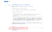
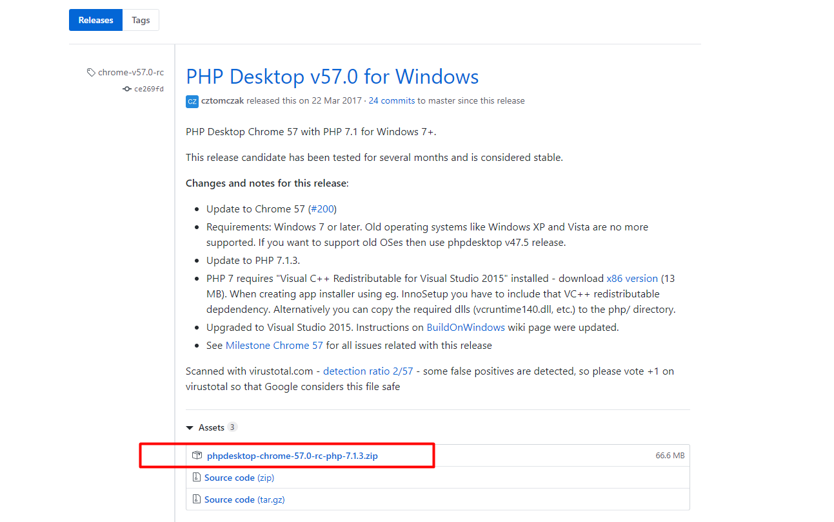
This package is from the author: cztomczak and acts as a web application container.
2- Creation of a laravel project
After downloading the “PHP DESKTOP” package, I invite you to generate a new laravel project by typing the following command in a command prompt:
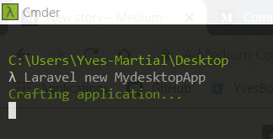
3- update of the php version
Change the php version of the “PHP DESKTOP” package from “php 5” to “php 7” because laravel works with this version of php.
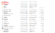
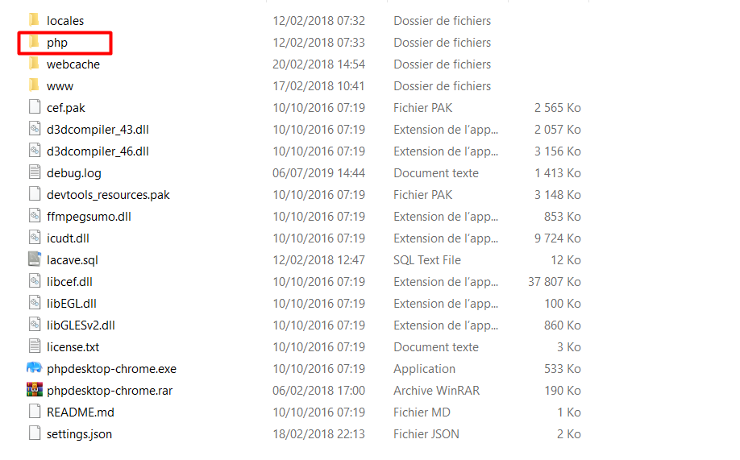
4- Copy of the “Laravel” project generated in the “MydesktopApp” folder to the “www” folder of “PHP DESKTOP”.
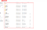
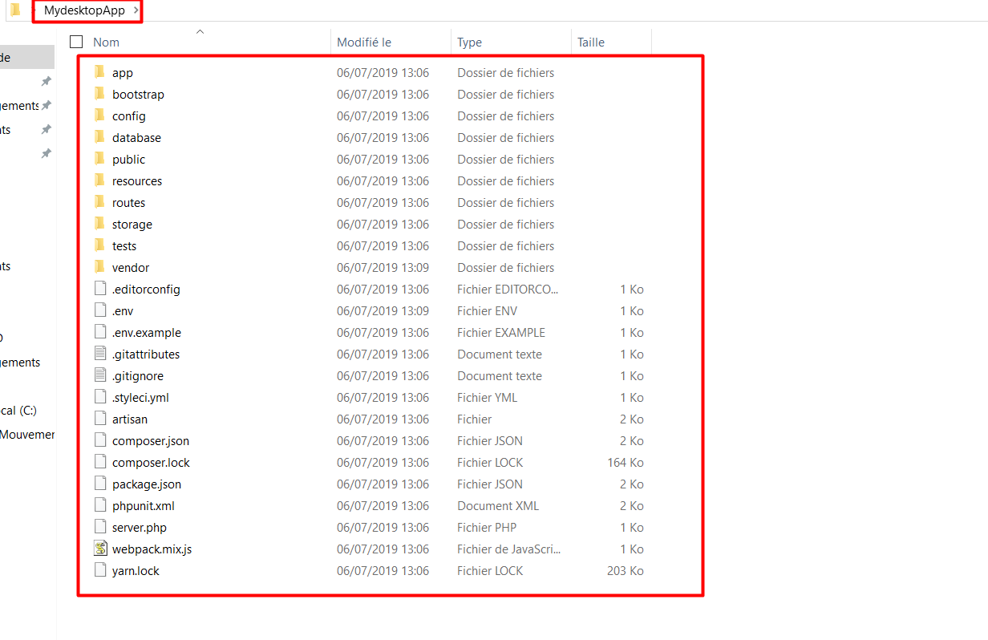
you will get this:
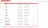
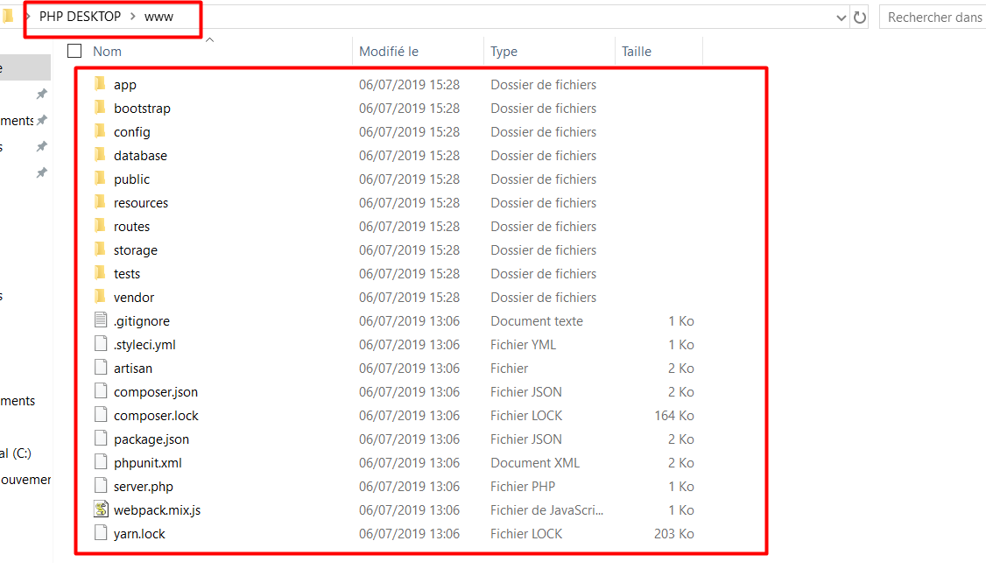
5- Configure the “settings.json” file to your convenience
“show_console”: false,
“title”: “MyAppDesktop”,
etc….
6- Launch the application and see the rendering
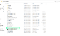
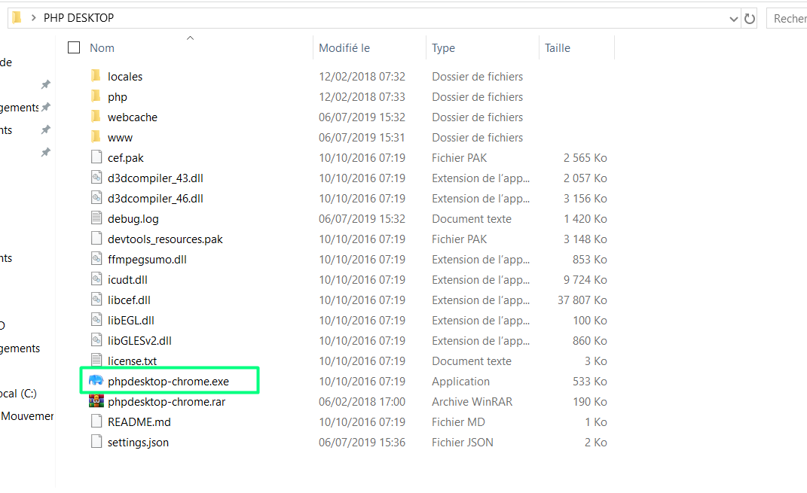
Rendering :

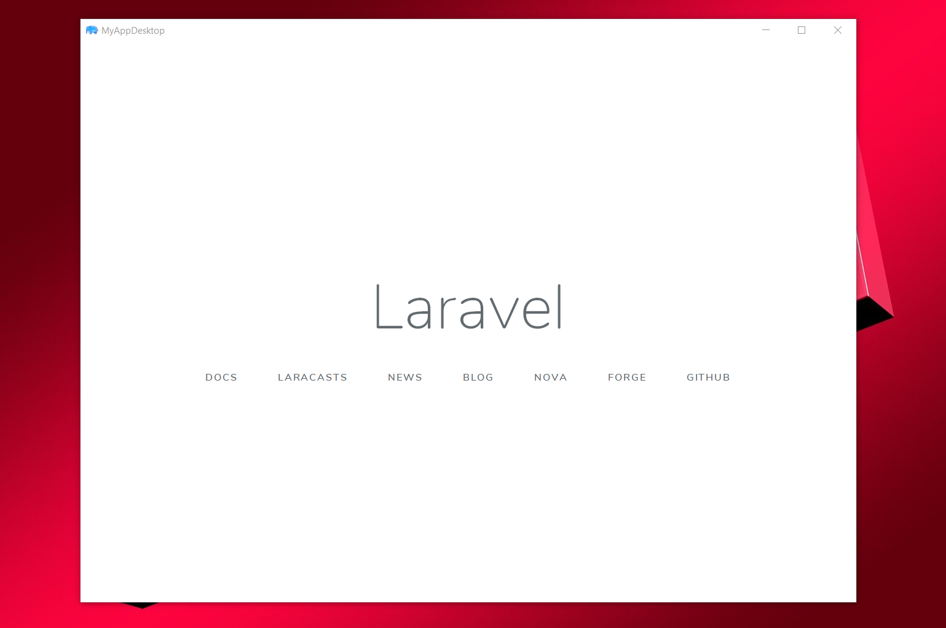
END.
Thank you for following this tutorial and invite you to subscribe to my medium page. and take a look at my youtube page:

Yves Martial Boah — Medium

Read writing from Yves Martial Boah on Medium. Every day, Yves Martial Boah and thousands of other voices read, write…
medium.com
https://www.youtube.com/channel/UCinw_GIoAs8tH8I_kUK76mA

Yves Martial Boah
- Laravel
- Desktop App
- Desktop
- PHP

More from Yves Martial Boah
Jul 6, 2019

Comment convertir une application web (Laravel) en une application desktop ?
TABLE DES MATIERES
1- Petite Introduction
2- Création d’un projet laravel
3- mise à jour de la version de php
4- Copie du projet “Laravel” générer dans le Dossier “MydesktopApp” vers le dossier “www” de “PHP DESKTOP”
5- Configurer le fichier “settings.json” à votre convenace
6- Lancer l’application et voir le rendu
1- Petite Introduction
Nous utiliserons ici un package nommé “PHP DESKTOP” disponible ici : https://github.com/cztomczak/phpdesktop/releases/tag/chrome-v57.0-rc
Télécharger le package comme cela est fait ci-dessous :
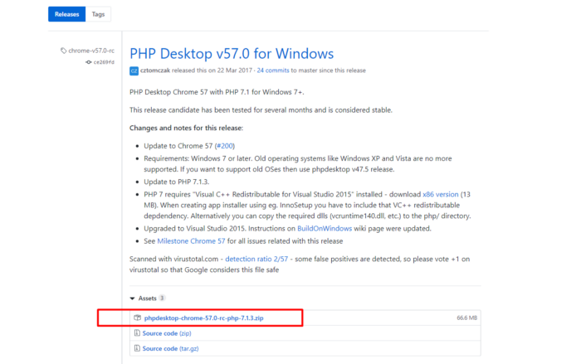
Ce package est issu de l’auteur : cztomczak et agit comme un conteneur d’application web.
2- Création d’un projet laravel
Après avoir téléchargé le…
Read more · 3 min read

Published in Flutter Côte D'Ivoire
·May 24, 2019

How to set up a basic Flutter webview from A to Z ?
TABLE OF CONTENTS
Small definition
1- Creating the project
2- Install the plugin: flutter_webview_plugin: ^0.3.5 in the pubspec.yaml
3- Write code to the main.dart file
4- Common Error
5- Error resolution
6- Executing the script

—
1 — Small definition
A webview is a web container, it allows your application to retrieve the content of a web page.
— -
2 — Create a project
flutter create webview_app

3 — Install the plugin: flutter_webview_plugin: ^0.3.5 in the pubspec.yaml
Read more in Flutter Côte D'Ivoire · 2 min read

Published in Flutter Côte D'Ivoire
·May 23, 2019

Comment mettre en place un webview en Flutter basique de A à Z.

TABLE DES MATIERES
- Petite définition
- Création du projet
- Installer le plugin : flutter_webview_plugin: ^0.3.5 dans le pubspec.yaml
- Ecrire du code dans le fichier main.dart
- Erreur courante
- Résolution de l’erreur
- Exécution du script

1 — Petite définition
Un webview est un conteneur web, il permet à votre application de récupérer le contenu d’une page web.

2 — Créer un projet
flutter create webview_app

3 — Installer le plugin : flutter_webview_plugin: ^0.3.5 dans le pubspec.yaml
Read more in Flutter Côte D'Ivoire · 2 min read

May 21, 2019

HOW TO GENERATE A PDF FILE WITH A PHP PASSWORD ?
TABLE OF CONTENTS
1- INSTALLATION OF THE MPDF LIBRARY
2- ANALYSE THE PREREQUISITES
3- IMPLEMENTATION OF THE PDF FILE GENERATION SCRIPT WITH PASSWORD
4- EXPLANATION
5- PRESENTATION OF THE GENERATED FILE
- BEGINNING -
1- INSTALLATION OF THE MPDF LIBRARY
The documentation of the mpdf library is available here via this link:
- https://mpdf.github.io/installation-setup/installation-v7-x.html
Its installation is as follows:
compose require mpdf/mpdf
This command is executed in the folder of your project
Example :
2- ANALYSE THE PREREQUISITES
Read more · 2 min read

May 21, 2019

COMMENT GENERER UN FICHIER PDF AVEC UN MOT DE PASSE EN PHP ?
TABLE DES MATIERES
1- INSTALLATION DE LA LIBRAIRIE MPDF
2- ANALYSER LES PRE-REQUIS
3- MISE EN PLACE DU SCRIPT DE GENERATION DE FICHIER PDF AVEC MOT DE PASSE
4- EXPLICATION
5- PRESENTATION DU FICHIER GÉNÉRÉ
— DEBUT —
1- INSTALLATION DE LA LIBRAIRIE MPDF
La documentation de la librairie mpdf est disponible ici via ce lien :
- https://mpdf.github.io/installation-setup/installation-v7-x.html
Son installation se fait comme suit :
$ composer require mpdf/mpdf
Cette commande s’exécute dans le dossier de votre projet
Ex :
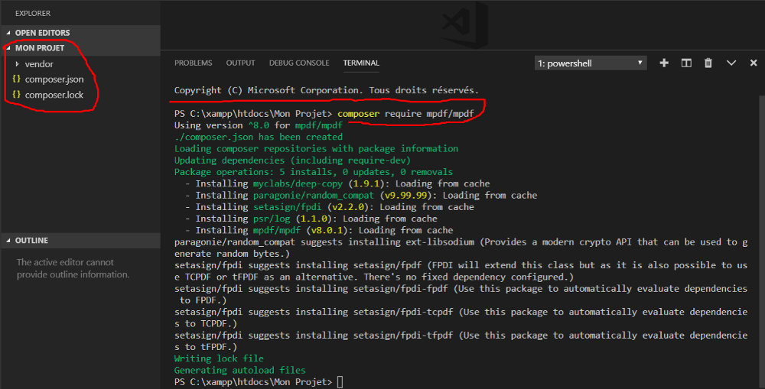
2- ANALYSER LES PRE-REQUIS
https://medium.com/@yvesboah/how-to-convert-a-web-application-laravel-into-a-desktop-application-995b876ae65e

